# Partnership registration

## Name of Partnership:

DooDle.AI

## Partners name:

1. Abhijith M
2. Sidharth N Babu

## Pancard

### Abhijith M

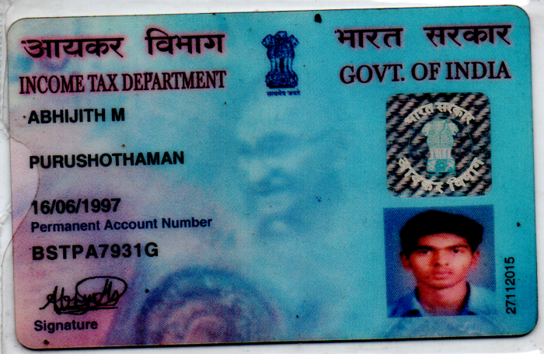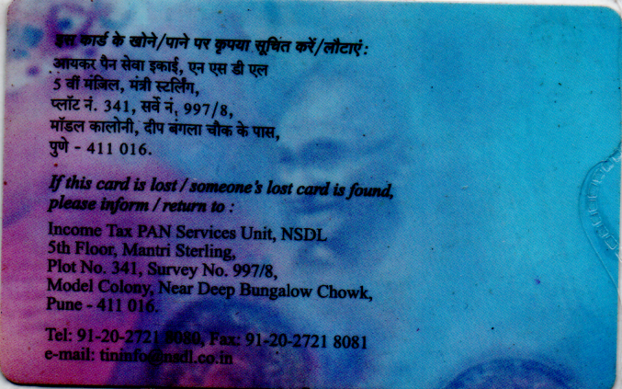

### Sidharth N Babu

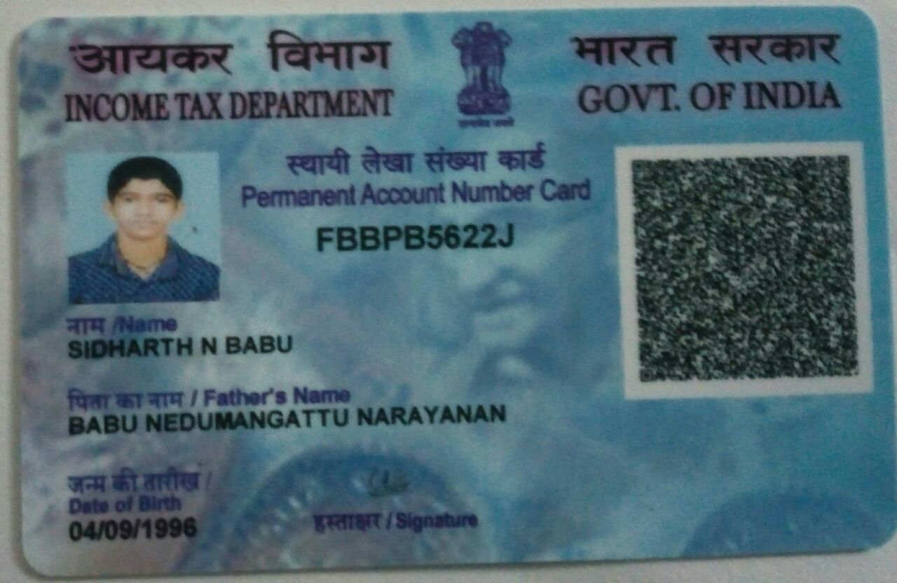

## Aadhaar

### Abhijith M

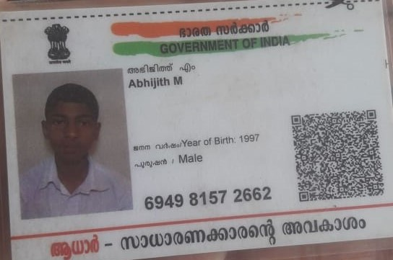

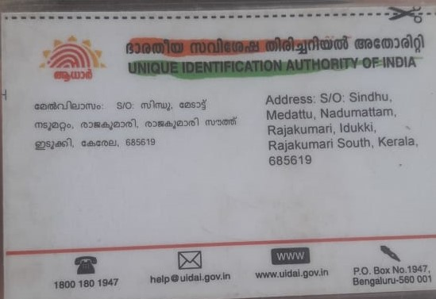

### Sidharth N Babu

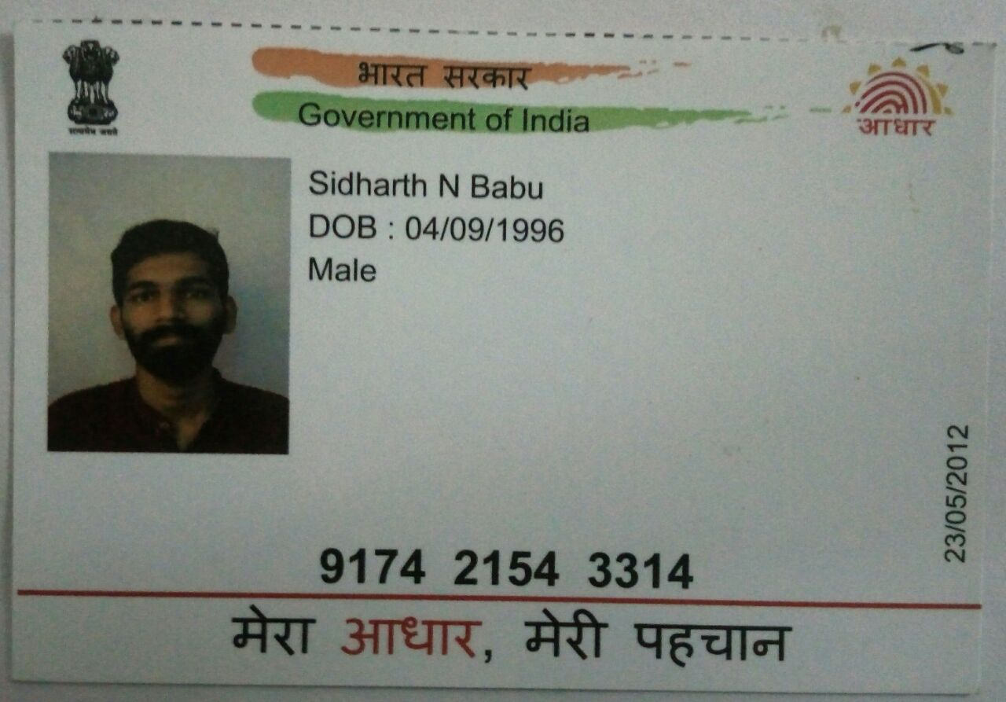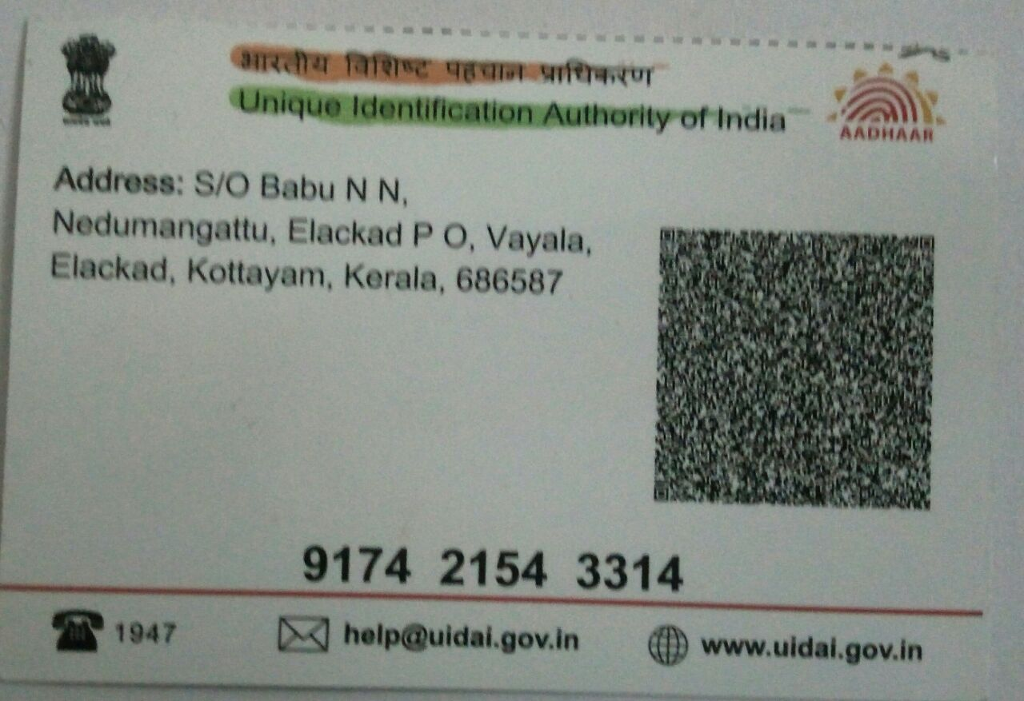

## Business Objectives

DooDle believed in AI and every day we innovate to make it better than yesterday. We believe in helping others to benefit from the wonders of AI and also in extending a hand to guide them to step their journey to adapt with future.

Our advanced AI capabilities have been utilized to create intelligent conversational tools for organizations to serve their customer queries automatically without human intervention. By analyzing queries, studying previous logs of successfully closed customer queries and other vital consumer parameters, our Chatbots offer a contextually sensitive answering service to customers.

AI comes to measure the human facial expressions to capture their moods. Emotion recognition is the process of identifying human emotion. People vary widely in their accuracy at recognizing the emotions of others. Use of technology to help people with emotion recognition is a relatively nascent research area.

Computer vision is a branch of artificial intelligence. The technology helps to automate visual understanding from a sequence of images, videos, PDFs, or text images with the help of AI and that allows computers to understand and label images. Computer vision is a field of artificial intelligence that trains computers to interpret and understand the visual world. Using digital images from cameras and videos and deep learning models, machines can accurately identify and classify objects — and then react to what they “see.”

## Principle place of business

Nedumangattu (H), Elakkad (P.O), Vayala, Kottayam, PIN: 686587

## Name of Managing Partner:

Abhijith M

## Profit sharing ratio:

1:1

## Bank operation:

Joint account

## Passport size photographs

### Abhijith M

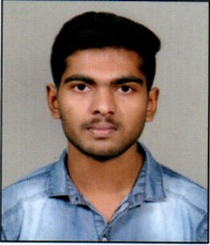

### Sidharth N Babu



## Mobile number

### Abhijith M :

+919447838962

### Sidharth N Babu:

+916282315225

## Email ID

### Abhijith M:

[abhijithm2447@gmail.com](mailto:abhijithm2447@gmail.com)

### Sidharth N Babu:

[sidharthbabu9@gmail.com](mailto:sidharthbabu9@gmail.com)